Colloquial Diction

🗨️ What is Colloquial Diction
# Source: Chatgpt (GPT-4-turbo) at [7/30/2025]
Colloquial diction refers to the use of regional, everyday, or informal language that reflects how people actually speak in casual conversations, often including idioms, contractions, and dialect-specific words.

✅ Key Features:
# Source: Chatgpt (GPT-4-turbo) at [7/30/2025]
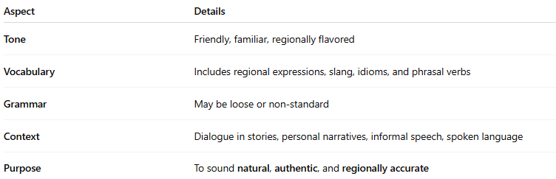
Aspect | Details
Tone | Friendly, familiar, regionally flavored
Vocabulary | Includes regional expressions, slang, idioms, and phrasal verbs
Grammar | May be loose or non-standard
Context | Dialogue in stories, personal narratives, informal speech, spoken language
Purpose | To sound natural, authentic, and regionally accurate

🧠 Examples:
# Source: Chatgpt (GPT-4-turbo) at [7/30/2025]
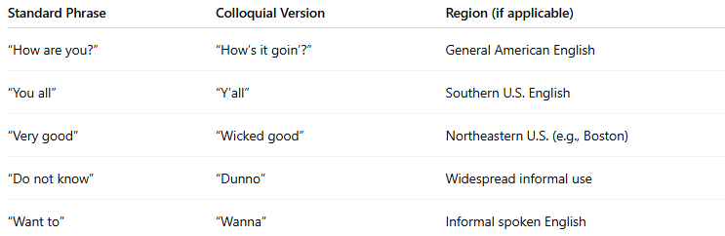
Standard Phrase | Colloquial Version | Region (if applicable)
“How are you?” | “How’s it goin’?” | General American English
“You all” | “Y’all” | Southern U.S. English
“Very good” | “Wicked good” | Northeastern U.S. (e.g., Boston)
“Do not know” | “Dunno” | Widespread informal use
“Want to” | “Wanna” | Informal spoken English

📚 Usage Examples in Sentences:
# Source: Chatgpt (GPT-4-turbo) at [7/30/2025]
“Y’all better get goin’ before it starts rainin’.”
“She’s gonna flip when she sees this mess!”
“That idea’s kinda sketchy, don’t you think?”

🧭 Common Uses:
# Source: Chatgpt (GPT-4-turbo) at [7/30/2025]
- Fictional dialogue to reflect character background
- Personal storytelling or speech
- Music lyrics and film scripts
- Creating realistic or relatable voice

🆚 Compared to Other Types:
# Source: Chatgpt (GPT-4-turbo) at [7/30/2025]
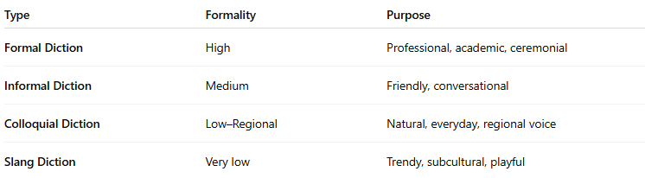
Type | Formality | Purpose
Formal Diction | High | Professional, academic, ceremonial
Informal Diction | Medium | Friendly, conversational
Colloquial Diction | Low–Regional | Natural, everyday, regional voice
Slang Diction | Very low | Trendy, subcultural, playful

